Assessment 1

# Difference between compiler and interpreter

|  |  |  |
| --- | --- | --- |
| **Comparison** | **Compiler** | **Interpreter** |
| Input | All the program is taken in a single time. | It takes an instruction or a single line of code at a time. |
| Output | It generates intermediated object code. | It does not generate any intermediate object code. |
| Working mechanism | Its compilation is done before execution. | Compilation and execution are done simultaneously. |
| Speed | Faster | Slower |
| Memory | The requirement of the memory is more due to the creation of object code. | Required lesser memory because it does not create intermediate object code |
| Error | Display all the errors after performing the compilation at the same time. | Display the error of every line one by one. |
| Error detection | Complicated and challenging | Easier as compare to complier |
| Example | C++, Scala | Python, PHP |

# Working of complier and interpreter

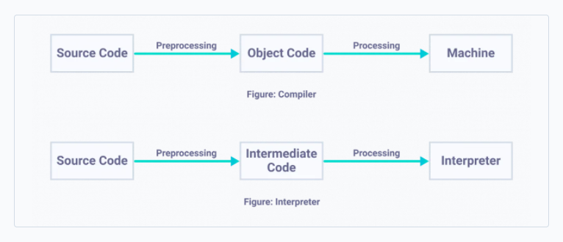

Figure Working model of compiler and interpreter